BRINK’S GLOBAL
CONTINGENT WORKFORCE
POLICY

TABLE OF CONTENTS
I. OBJECTIVE 3
II. DEFINITIONS 3
III. SCOPE 4
A. Geographical Scope 4
B. Roles in scope for policy 4
Contingent Workforce 4
C. Roles out of scope for policy 4
Brink’s employees 4
Internships 4
Frontline Workers 4
Business Process Outsourcing (BPO) firms 4
Consulting Projects 5
IV. RULES FOR ENGAGING CONTINGENT WORKERS 6
A. Overall Decision-Making Process 6
B. Global Preferred Supplier List 6
C. Engaging Strategic Sourcing 7
Engaging Contingent Workers 7
Approval to Recruit 7
Assignment Length 7
Assignment Extensions 7
Worker tenure separation period 7
Assignment Overtime 8
Furlough 8
Referred Hires 8
Expenses and Reimbursements 8
Risk Management 8
On-Boarding Instructions 9
Notice period 9
Temporary to permanent transfers (temp2perm) 9
V. ROLES AND RESPONSIBILITIES 9
VI. Local Adaptation Guidelines 10
Steps for Adaptation 10
1. Review and Assessment 10
2. Local Contextualization 10
3. Approval Process 10
4. Communication & Training 11
5. Monitoring & Reporting 11

OBJECTIVE
As part of our initiative to better manage and control spending on our contingent workforce, we are introducing this policy to optimize the sourcing of these services. Our objective is not only to reduce costs but to boost operational efficiency, and create greater overall value for the company, by strengthening and standardizing our processes globally. Failure to comply may result in the immediate cancellation of the request or renegotiation of the agreement, as permitted by applicable law.

This document provides a comprehensive framework for managing external workforce engagements across all Brink’s legal entities. It includes key guidelines, such as the use of preferred supplier lists and assignment rules, while also ensuring a clear distinction between contingent workforce (temporary labor and contractors) and output-based hires.

DEFINITIONS
- Co-Employment: A legal term where both Brink’s and the staffing agency may be considered employers of a contingent worker due to Brink’s involvement in their supervision, salary review, or performance management. This situation can lead to legal claims regarding employee benefits and rights.
- Contingent Workforce: Refers to a group of non-permanent workers employed on a flexible, as-needed basis to meet business needs. These workers include temporary labor provided by staffing companies, independent contractors, freelancers, and other short-term or project-based workers engaged through agreements or contracts also commonly referred to as contingent workers. These workers typically operate under fixed durations or specific statements of work and are compensated on a time-and-material basis, such as hourly or daily rates.
- Contingent Worker: A non-permanent worker typically engaged through a staffing company for a fixed duration. Contingent workers are paid on a time-and-material basis (e.g., hourly or daily rates).
- Knowledge Worker: An individual whose primary job involves handling or working with information, intellectual capital, and specialized knowledge rather than manual labor.
- Master Service Agreement (MSA): A contract between Brink’s and a supplier outlining general terms for future transactions or agreements, including terms like payment, confidentiality, and dispute resolution.
- Output-Based Hire: Engagements where consultants or firms are hired to deliver a specific output or result, with compensation based on deliverables rather than time worked. These engagements are project-based and focus on strategic advisory or specialized services.
- Preferred Supplier List: A pre-approved list of vendors with existing global or regional contracts offering competitive pricing and discount structures. These suppliers are the exclusive providers for contingent workforce services, except in circumstances outlined in this policy.
- RFx is a general term used to refer to various “Request For” strategic sourcing processes that organizations use to solicit information, proposals, or quotes from suppliers or vendors.
- Statement of Work (SOW): A sub-agreement to the MSA that details the specific services, deliverables, timelines, and pricing for a given project or engagement.
- Supplier/Vendor: A third-party entity contracted to provide goods or services to Brink’s, such as staffing companies or service providers for contingent workforce or project-based services.
- Time-and-material hire refers to a type of employment or contractual arrangement where the worker is paid based on the amount of time they spend working (e.g., hourly or daily rates) and the materials or resources used to complete the work. This model is commonly used for contingent workers, freelancers, and contractors who are hired for short-term assignments or projects.

SCOPE

Geographical Scope

This Policy and guideline apply to all Brink’s entities globally and their associated procurement activities related to contingent workforce.

Roles in scope for policy

Contingent Workforce

Temporary Worker
An employee of a staffing company who is recruited, screened, and sometimes trained by the staffing company to perform work for an organization with the expectation that the work will be for a fixed duration. Includes workers with the skills, knowledge, and training required for occupations in light industrial, office/clerical, general labor, accounting, and finance, legal, marketing, and creative, engineering, technology, research and development, human resources, and any other similar services.
Contractor
An individual retained to deliver a specified service as laid out in a contract and/or statement of work. Includes self-employed individuals, freelancers, and individuals who perform short-term jobs that are unaffiliated with a particular employer organization, although they may be affiliated with one or more staffing companies. Further defined in table below.

Roles out of scope for policy

Brink’s employees
Permanent or temporary employees paid directly by Brink’s (on Brink’s payroll). They do not have a predetermined end date to employment except for some short-term employees who are paid via Brink’s Payroll. In addition to their wages, they often receive benefits like subsidized health care, paid vacations, holidays, sick time, or contributions to a retirement plan. Please note that permanent and temporary workforce includes both a full-time employee (FTE) and employees working part time.

Internships
An intern may be a temporary employee who is a student or has recently finished their studies and is receiving training by obtaining practical experience of a type of work. The duration of an internship should not last for more than 12 months, subject to applicable law.

Frontline Workers
A frontline worker is considered an employee directly involved in our operations (e.g. contingent workforce hired in our cash processing centers). Interim, short-term, temporary, or seasonal frontline workers working on production lines, providing general labor support or other similar services are also not included in the scope of this policy.

Business Process Outsourcing (BPO) firms
Business process outsourcing (BPO) is defined as the outsourcing arrangement where business functions (such as finance, accounting, and customer service) are outsourced with no intention of ever insourcing back the function. Engagements with BPO firms last at minimum three years. For example, IT support activities performed by a company such as Infosys are under BPO.

Law firms
A law firm is a business entity formed by one or more lawyers to provide legal advice to clients, represent them in legal disputes, and handle matters such as contracts, litigation, and negotiations. Selecting and hiring law firms is governed by the Brink’s Legal Services Policy.

Consulting Projects
Consulting projects involve firms or individuals compensated based on the delivery of a specific output or result, rather than the time spent. Consultants are engaged to provide strategic advice or specialized services, and their fees are typically fixed, or project based.

See below further clarification:

Criteria | Contingent Workforce (In Scope) | Consulting Projects (Out of Scope)
Work defined by: | A time bound role of maximum 12 months, defined by a Job Description | A service with clearly defined deliverables and milestones for activities shorter than 24 months
Payment | Based on time and material (e.g. bill rate per hour) | Based on delivery and completion of outputs and milestones
Individual profiles | Individual profiles are determined by Brink’s, such as selection of a specific candidate. | Individual profiles not determined by Brink’s and selected at supplier’s discretion.
Supervision | Directed by Brink’s (such as the hiring manager) | Directed by the supplier (such as the supplier account manager)
Temp to Hire | Contingent workers may convert to permanent employees at Brink’s unless self-employed. | Brinks cannot permanently hire consultants unless they are willing to change employers, and this is not contractually prohibited.
Liability | Falls on Brink’s (Brink’s is liable and responsible for the delivery and quality of the outcome) | Falls on the supplier (Brink’s is not liable and responsible for the delivery and quality of the outcome)
Examples | Brink’s is hiring a web developer paid by the hour under the direct supervision of the hiring manager for 5 months. The worker is not liable for the quality of his work. Since this worker is under direct supervision of a Brink’s manager, Brink’s remains owner of the Intellectual Property but also responsible for the quality of the work. | A firm hired to deliver a website for Brink’s within one year. The specifications are clearly defined for the website (such as content, UX, or SEO). Payment is released upon completing milestones with specific deliverables.
* There could be a specific situation when an individual is paid based on both the amount of time & material worked and based on a delivery of at least one outcome. In this scenario, the respective resources will be treated as Contingent Worker (within scope) unless exceptional approval is provided by local HR Business Partner.

For consulting services, please refer to the Global Professional Services Policy.

RULES FOR ENGAGING CONTINGENT WORKERS

Overall Decision-Making Process
The decision-making process below is utilized when a need for a Contingent Worker is identified:
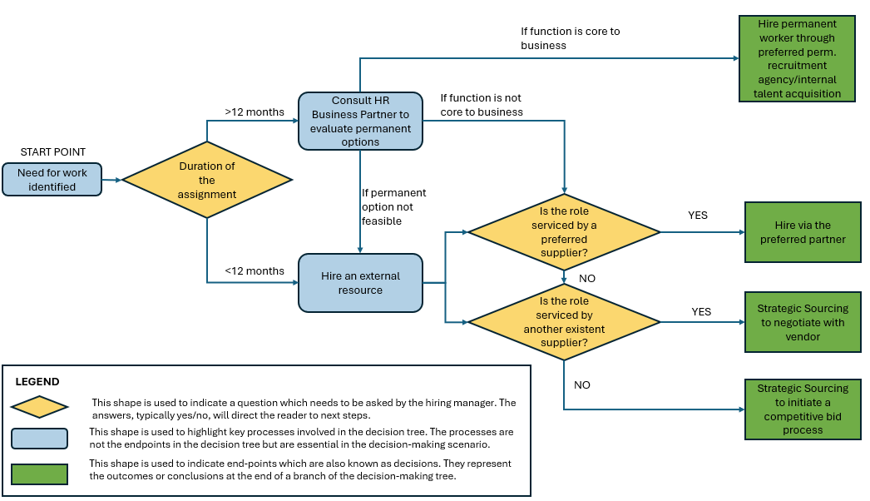

Global Preferred Supplier List

As of 1st November 2024, Brink’s has two global preferred vendors – Robert Half and Adecco. These vendors are to be prioritized for all Contingent Worker requirements.

# | Supplier Name | POC Name | POC E-Mail
1 | Adecco Group | Jeney James | Jeney.James@adeccona.com
2 | Robert Half | Jenifer Mauney | jenifer.mauney@roberthalf.com

If none of the vendors listed above can meet a specific requirement, Strategic Sourcing must be consulted to explore alternative options.

Local contracts and rate cards have been negotiated for the US, France, and the Netherlands. For other countries, please contact your local Strategic Sourcing team to assist with implementing these vendors as soon as a need for a Contingent Worker arises. Since Brink’s is partnering with these vendors as part of a global program to secure preferential pricing, it is essential that they are not engaged on an ad-hoc basis locally.

Engaging Strategic Sourcing
When a preferred supplier is not able to meet the requirements of the Business Stakeholder/HR Partner, Strategic Sourcing will engage to select an alternative vendor. Strategic Sourcing will follow the below steps:

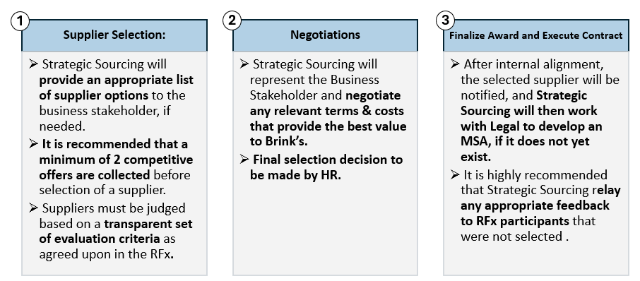
Engaging Contingent Workers

The following rules and set of instructions are applicable where hiring managers wish to engage contingent workers. For example, engaging a Temporary Worker for 6 months while a permanent employee is on extended leave.

Approval to Recruit
All new Contingent Worker requests require the approval of the HR Business Partner. It is the responsibility of the HR Business Partner to ensure all new engagements comply with this policy and to work with Strategic Sourcing if needed.

Assignment Length
The length of an assignment should not exceed more than 12 calendar months. The local HR Business Partner is responsible for keeping track of expiring contracts.

Assignment Extensions
Any assignment can be extended beyond 12 calendar months by obtaining formal approval from the Regional VP/SVP Human Resources and Regional General Counsel. In some countries the number of extensions possible is limited. In these scenarios, please follow the local legislation and contact the local HR business partner.

Worker tenure separation period
Subject to applicable law, if the 3-month break is to be waived, prior legal consultation and alignment are required. It is important to note that the 24-month limit applies to the worker's total tenure with Brink’s, not to the duration of individual assignments. Therefore, the time between the worker’s initial start date with Brink’s and any potential extension cannot exceed 24 months in total. For example, if a Contingent Worker is hired for three consecutive assignments, each lasting 8 months, the cumulative tenure would reach 24 months. In this case, the worker should not extend, even if the new assignment is for a different project or requirement.

Assignment Overtime
Working overtime (or more than the agreed upon hours) is not allowed and will not be compensated without the approval of the relevant Brink’s business leader for all contingent knowledge workers, unless compensation for unauthorized hours worked is required by applicable law.

Furlough
Furlough is applicable for all contingent Knowledge Workers according to local legislation.

Referred Hires
The practice of a Brink’s employee referring external hires—where a specific external worker is selected for employment without undergoing a competitive selection process—is strictly prohibited. Brink’s is an equal opportunity employer. This policy ensures that hiring decisions are made transparently and fairly, allowing all potential candidates equal opportunity to compete for positions. It also mitigates risks associated with favoritism, reduces the likelihood of non-compliance with internal policies, and aligns with company standards for fairness and cost-effectiveness in staffing. In exceptional cases where a referred hire is considered necessary—such as when a candidate possesses unique skills or experience critical to a project—proper justification must be provided. Any exceptions require approval from the Regional VP/SVP Human Resources to ensure that the hiring decision is aligned with broader organizational goals and compliant with procurement policies. Only after receiving such approvals can the recruitment process proceed with the named individual.

Expenses and Reimbursements
Expenses and reimbursements of the expenses are to be aligned with the Brink’s travel policy: Brinks Global Travel and Expense - Home.

Risk Management
Co-employment arises when a company, such as Brink’s, takes certain actions towards Contingent Qorkers that blur the line between contractor and employee. These actions include, but are not limited to, salary and benefit reviews, performance counselling, interviewing, participation in leadership meetings, town halls, celebrations, or termination of employment. In such cases, Brink’s could be found to be the legal "co-employer" of the contingent worker despite not directly employing the individual, which may expose the company to significant legal risks, including claims for employee benefits and employment rights.

It is crucial to avoid treating contingent workers as if they are permanent or temporary employees. Engaging them in activities such as team meetings, leadership events, or employee-focused programs can lead to legal claims of de facto employment, particularly in countries with strict labor regulations.

How to mitigate co-employment risk:

- No assignment should extend beyond 12 months.
- Temporary labor engaged through a temporary labor agency should be interviewed by the agency.
- Agencies that provide temporary labor should manage all matters relating to pay, vacation, time off, sick leave, performance, and career development.
- Independent contractors are responsible for all tax implications and withholdings resulting from their work with Brink’s.
- Contingent workers should be identified as such on their ID badge, email signatures, phone lists, organization charts, in Microsoft Outlook, etc.
- Contingent workers should not be given an internal Brink’s title
- Contingent workers should only be invited to company meetings on a “need-to-know” basis.
- Contingent workers should not attend company events, trainings, or external events.

Any exception to the above should be approved by Legal.

On-Boarding Instructions
Background screening to be performed before on-boarding the Contingent Worker will be done according to local legislation and applicable company policy. Contingent Workers will be provided with all necessary equipment (i.e. laptops).

Notice period
For the off-boarding procedure, the Contingent Worker is subject to minimum legal duration of each countries’ legislation.

Temporary to permanent transfers (temp2perm)
Except for self-employed Contingent Workers such as freelancers, all contingent worker assignments need to have a temporary to permanent clause, where Brink’s has a possibility to offer workers a permanent position after a specific amount of time.

ROLES AND RESPONSIBILITIES

Responsible | Details
Business Unit Manager or Hiring Manager | Management, selection, and hiring processes related to contingent employees
Strategic Sourcing | Sourcing, negotiation, and interaction with the concerned suppliers
HR and Strategic Sourcing Teams | Policy maintenance and governance
Global HR Leadership Team & Legal | Endorsement of the global policy; approvals for policy deviations

Policy escalations need to be directed to: Angela Gambaro, Vice President Global Talent Acquisition.

The Global Strategic Sourcing team members are listed below:
Country | Name | Email
US | Hugh Mouden | hugh.mouden@brinksinc.com
France | Petronela Skorkova | p.skorkova@brinks.fr
Netherlands | Mohamed Barry | mohamed.barry@brinks.com
Romania | Raluca Miron | raluca.miron@brinks.com
Czech Republic | Petr Zbozinek | petr.zbozinek@brinks.com
Brazil | Adriano Bronzatto | adriano.bronzatto@brinks.com.br
Colombia | Erika Rodriguez | erika.rodriguez@brinks.com.com
Chile | Eduardo Varetto Ramos | EVaretto@brinks.com
Mexico | Ricardo Madrazo | ricardo.madrazod@panamericano.mx

Local Adaptation Guidelines

This policy was set at a global level to create standardization across the enterprise. The policy is intended to provide all Brink’s countries with general guidance and guardrails to ensure we manage expenditure in a smart, disciplined manner.
However, as part of the implementation, each country may need to review this policy and provide additional context as to how it will be operationalized to account for local variations. There may be scenarios where the global policy:

- conflicts with local compliance
- is less stringent than existing local practices or policies
- provides directional guidance for country operationalizing – for example, if VP approval is required, each country can determine which specific VP, or equivalent role will provide that approval.

In instances where local laws, policies, or practices conflict with the Global Contingent Workforce Policy, local laws will supersede this Policy.

Steps for Adaptation

1. Review and Assessment
- Gap Analysis: Identify areas where the global policy:
  - Conflicts with local regulations.
  - Is less stringent than existing local policies.
  - Requires additional clarity for practical application.
- Compliance Check: Ensure alignment with all applicable local laws and regulations.

2. Local Contextualization
- Develop a localized version of the policy that:
  - Maintains the intent of the global policy.
  - Integrates stricter or unique local requirements.
  - Provides clear, actionable steps for operationalization.

3. Approval Process
Adaptations to the global policy must undergo the following approval steps:
- Draft Proposal:
Submit a detailed proposal outlining:
  - The identified local variation or conflict.
  - The rationale for the proposed adaptation.
  - Evidence of compliance with local regulations.
- Review by Regional General Counsel:
Ensure the proposed adaptation complies with legal requirements and does not expose Brinks to unnecessary risks.
- Review by HR VP/SVP:
Confirm alignment with HR objectives, policies, and enterprise standards.
- Final Approval:
Approval by both the Regional General Counsel and Global CHRO are mandatory before implementation.

Template for Local Adaptation Submission

Section | Details
Country/Region | Specific country or region where adaption is necessary
Global Policy Reference | Identify the specific section of the global policy
Local Variation Identified | Described the conflict/issue with global policy
Proposed Adaptation | Outline the proposed changes or additions
Compliance Justification | Provide evidence of compliance with local regulations
Implementation Plan | Detail how the adapted policy will be operationalized
Approval Signatures | Include lines for signatures of the Regional GC & CHRO

4. Communication & Training
- Provide training sessions to local teams to ensure understanding and adherence to the adapted policy.
- Communicate the rationale behind adaptations to promote consistency and buy-in across the organization.
- Send final adaptation including approval signatures to Brinks Resource Library under Global Legal Policies

5. Monitoring & Reporting
Establish regular reviews of the policy (minimum one time a year) to ensure:
- The adapted policy remains compliant with local and global standards.
- Feedback from implementation is used to refine future adaptations.

