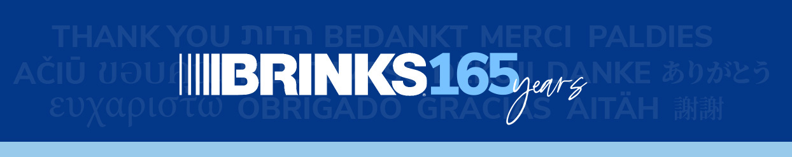

ABOUT THIS TOOLKIT
This toolkit includes materials designed to help us easily and consistently communicate about our anniversary and some exciting transformation work underway that will help us build a stronger Brink’s.

Graphics
We’ve provided graphics in a variety of file formats to equip you to promote the anniversary across digital and print channels. They include:
- 165 logo – an English version and a universal version, both in color and reversed out to work on colored backgrounds. In the digital folder, use the .jpg or .png files for PowerPoint presentations, screen savers, digital boards, email signatures, etc. In the print folder, use the .jpg . eps or .tif files for balloons, cakes, gift items, etc.
- Editable posters – letter and A4 formats produced in English, Spanish, Portuguese and French; you can replace the “thank you” graphic and the copy as desired; feel free to translate or write your own message.
- Teams backgrounds – English, Spanish, Portuguese and French versions.
- Email headers – produced in white and blue; feel free to use the banner on email communications about the anniversary to your employees.
- LinkedIn posts – an English version and a universal version you can use with your own copy; both are animated and will continuously run through the list of “thank you’s” in languages spoken by Brink’s employees around the world. We also provided a static version with just the universal 165 logo; feel free to write your own copy to go along with the universal graphics.
- What’sApp graphics – two universal versions, one animated and one static; feel free to write your own copy to go along with the graphic.

Editorial Materials
Use these materials to engage your employees.
- Key messages (not for broad distribution) – to be used as a basis for all communications
- FAQs (for reactive use only; not for broad distribution)
- GM/leader letter to employees – please customize for your leader as desired
- [COMING SOON] Leader PowerPoint Presentation and Talking Points (for use by leaders; not for broad distribution)
- [COMING SOON] Mark Eubanks employee letter – please translate as needed; do not change/edit the message

Video Message from Mark Eubanks
We produced a short video message from Mark Eubanks (in English). We are initially making it available with subtitles in Spanish, Portuguese and French. If you need another translation, please complete the translation table in this folder and send it to Kaye Faris at kfaris@brinkscompany.com.

Please use the downloadable video (password: anniversary) for internal presentations, and the shareable video in email communications.

