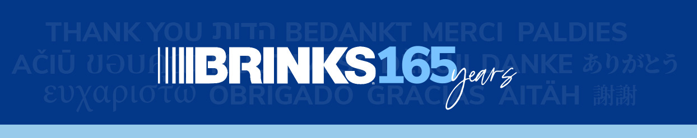

KEY MESSAGES

Celebrating Brink’s 165th Anniversary

- On May 5, we will reach Brink’s 165th anniversary.
- We are proud to be one of a very few number of global organizations that have reached this milestone.
- Today, Brink’s is a globally recognized brand with a rich heritage of trusted service and valued partnership.
- We traditionally celebrate Values Day on May 5, but on this milestone occasion, we want to celebrate YOU, and all our Brink’s employees.
- Thank you for all your hard work, each and every day. It’s what will define Brink’s legacy for years to come.
- Our employees are what makes Brink’s such an amazing company. You shape our culture, drive innovation and serve our customers.
- It’s the employees of Brink’s who make this company great.
- We look forward to the bright future we’re building together as we transform our business and find new ways to serve our customers.

Transformation

- At 165 years old, we’re just getting started.
- We have some exciting work underway that will better define who we want to be in the future and how we’re going to get there.
- We are building upon previous efforts to rethink the way we work, with our BBS buildout, Lean expansion, Workday deployment and first global engagement survey.
- This year, we will be refreshing our values, investing in talent programs to improve our work environment based on your engagement survey feedback and improving our core infrastructure to help us operate better – as one global team.
- The changes we’re making will incorporate the values that have made Brink’s the company we are today, while challenging us to be an even better company for the future.
- This work will power a culture shift, strengthen the connection between local and global operations, drive innovation, and modernize our organization.
- Ultimately, we aim to position Brink’s to thrive for another 165 years.
- We will be communicating more about our Brink’s transformation initiatives throughout the year.
- We hope you’re excited about this opportunity to reimagine Brink’s for the future and shape our legacy for the next 165 years.

