Nominate yourself,   
a co-worker or a team.

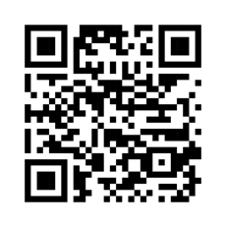

Scan this QR code with your phone   
for the online nomination form

**Deadline: January 12, 2024**

Nominate yourself,   
a co-worker or a team.



Scan this QR code with your phone   
for the online nomination form

**Deadline: January 12, 2024**

