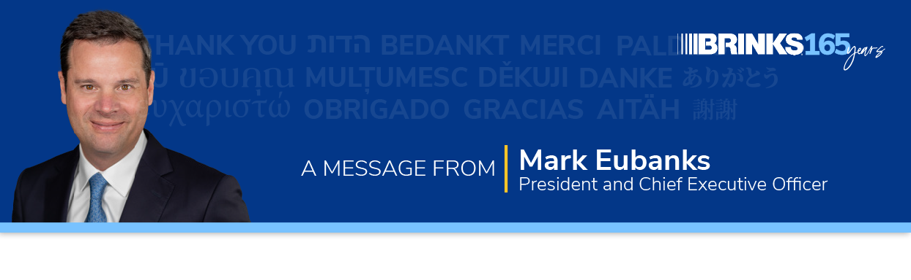

Subject Line: May 5 is Brink’s 165th Anniversary

Dear [team],

On May 5, Brink’s will turn 165 years old. I am proud and humbled to work at one of the very few companies that’s achieved this milestone. We’ve done it by building valued partnerships and delivering trusted service time after time, year after year. Today Brink’s is a globally recognized brand with a rich heritage.

That’s why on this milestone occasion, we are celebrating YOU and every other Brink’s employee who helped us get here. You’re the heart of our company. You shape our culture, drive innovation and serve our customers, and I am grateful for your dedication.

Looking Ahead
While it’s important to reflect on where we’ve been, we also must plan for our future.

Companies that thrive this long typically have one thing in common: the willingness to keep reinventing themselves. Brink’s is no exception, and we have some exciting work underway to push our transformation further by better defining what we want to be in the future and how we’re going to get there.

This initiative builds upon previous efforts to rethink the way we work, like our Lean expansion, Brink’s Business System (BBS) and our global engagement survey. Soon we will introduce a purpose statement and updated values that will power our transformation. We also are continuing to invest in talent programs to enhance our work environment and taking additional steps to improve our core infrastructure to help us operate better – as one global team.

More to Come
You will hear more about these efforts from your local leadership team. While change is inevitable, it’s vital for our success. Our ability to embrace change will determine our ability to thrive.

You’ve played a critical role in our past and will play a critical role in our future. Transforming Brink’s demands that we constantly strive to be better than we were yesterday.

I hope you’re as excited as I am about our journey to shape our legacy for the next 165 years.

Happy anniversary, and thank you for all you do!

Mark

