**8 WASTES**

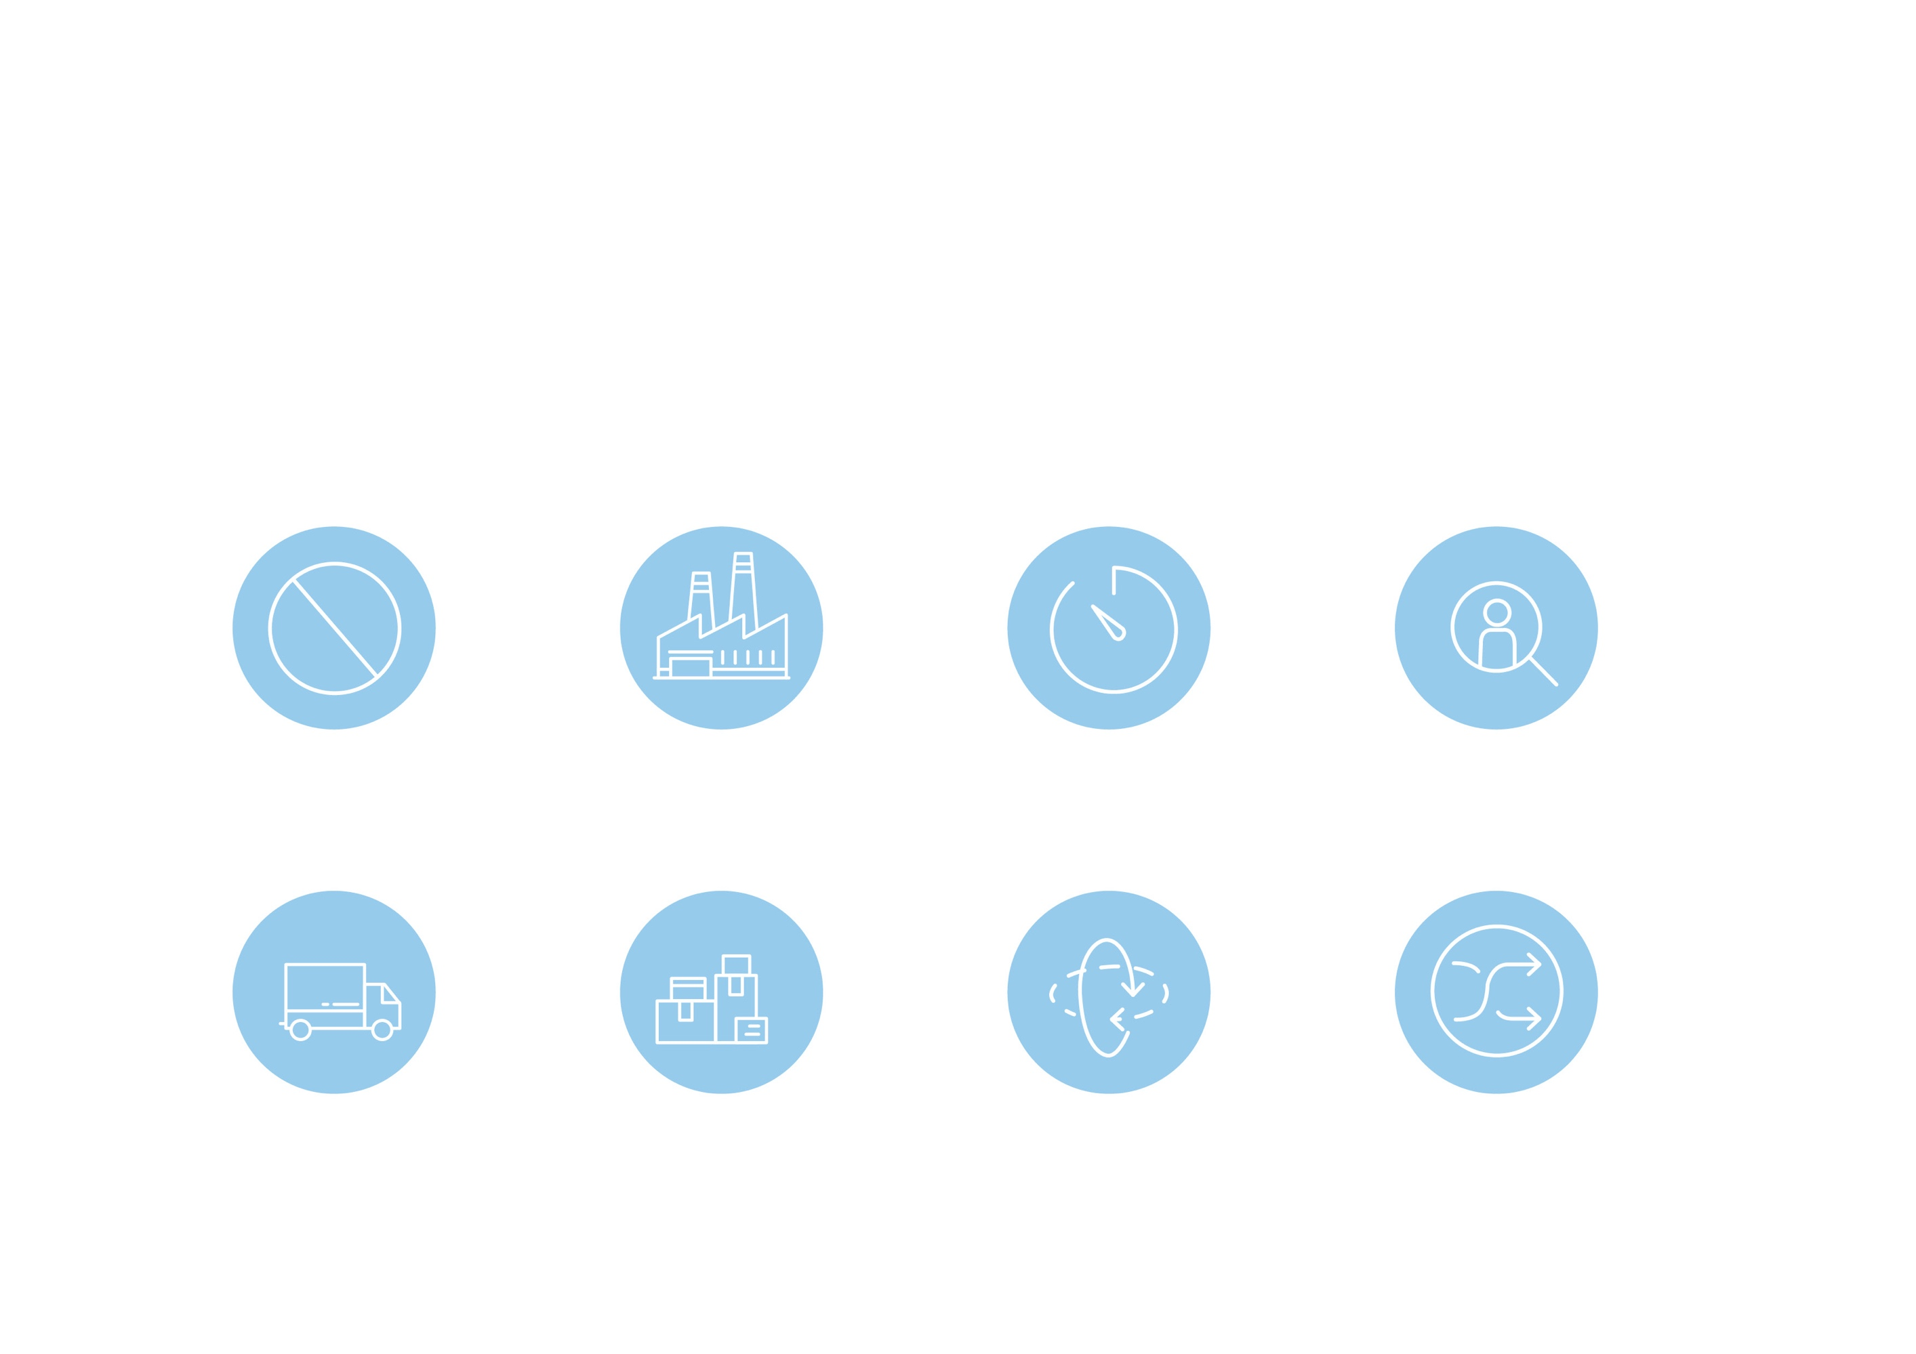

**DEFECTS**

**OVERPRODUCTION**

**WAITING**

**NON-UTILIZED TALENT**

**TRANSPORTATION**

**INVENTORY**

**MOTION**

**EXTRA PROCESSING**

