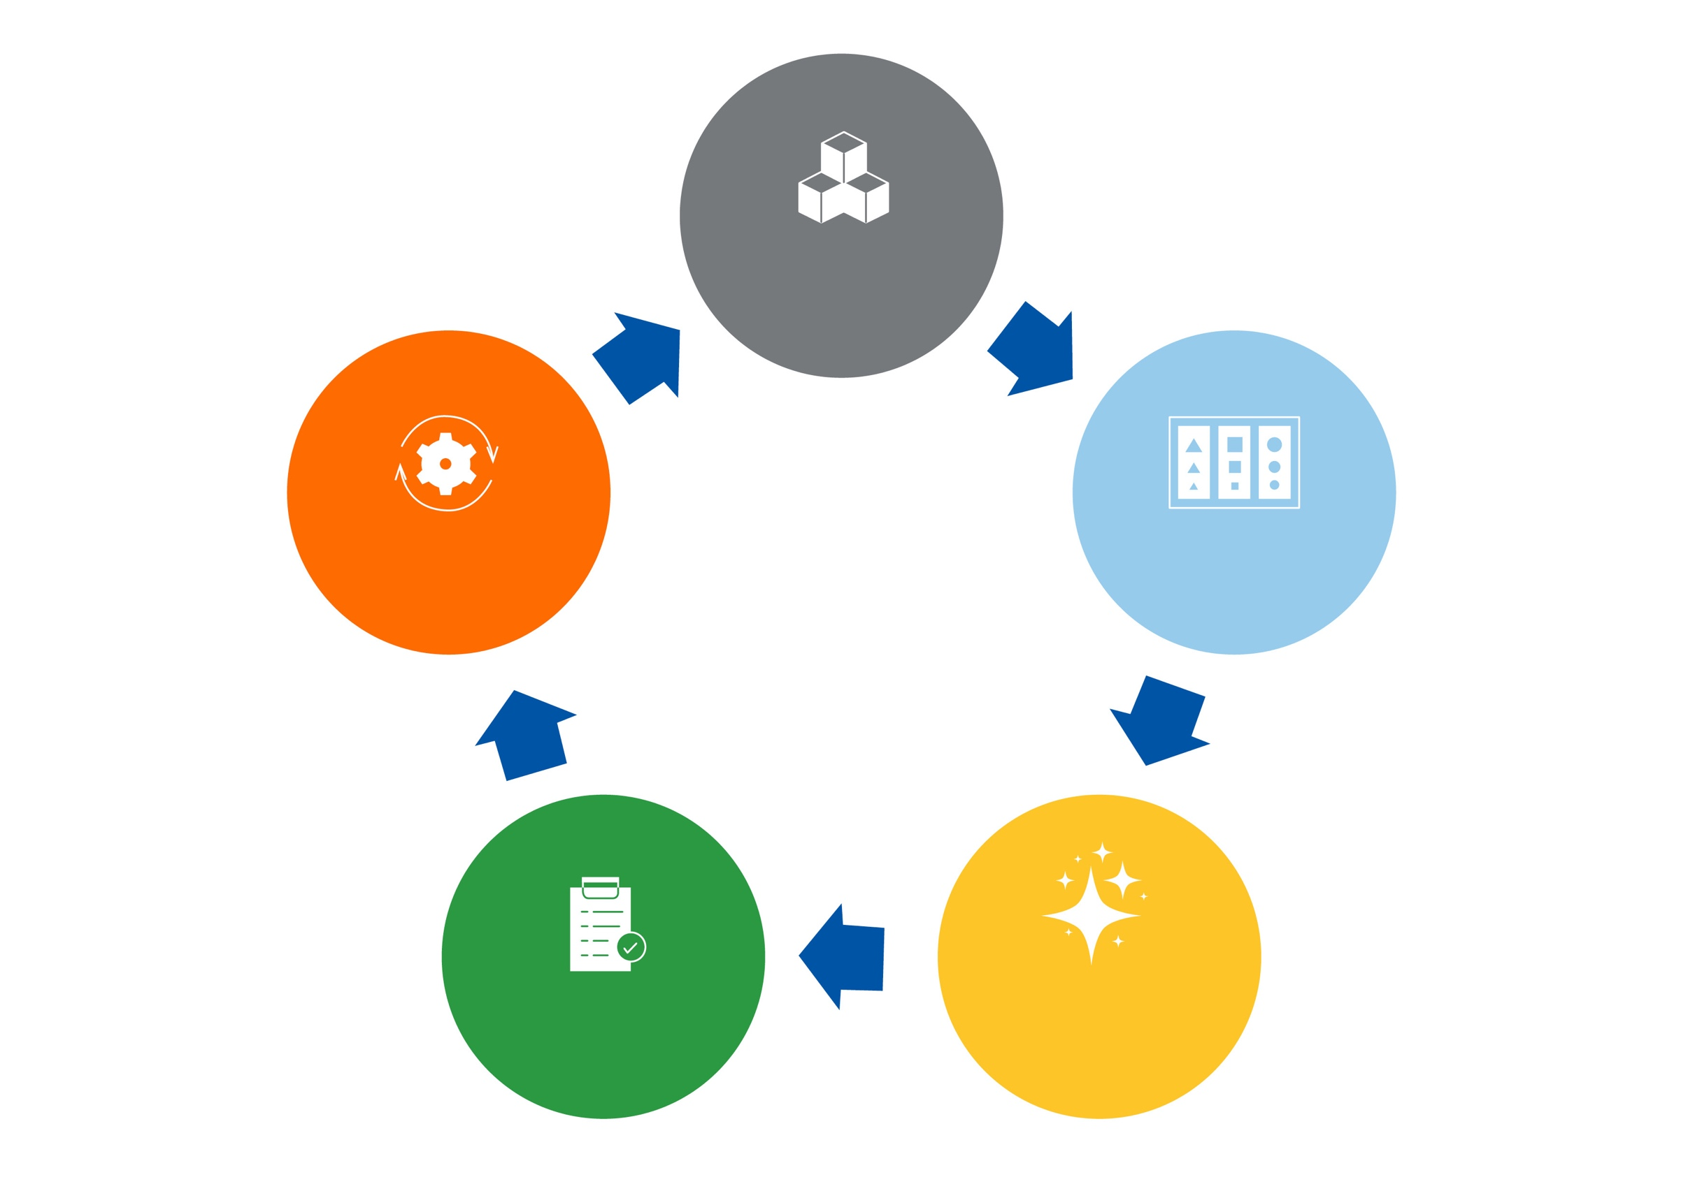

**5S**

**STANDARDIZE**

**SORT**

**SET IN ORDER**

**SHINE**

**SUSTAIN**

