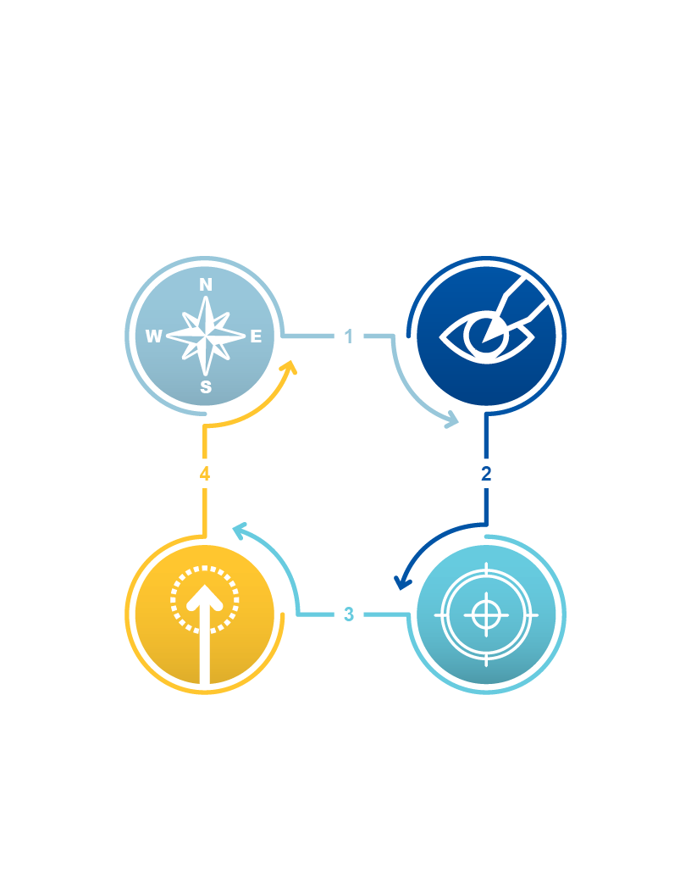

Improvement kata is a repeating four-step routine by which   
an organization improves and adapts. Kata is a term from Japanese martial arts that means daily practice routines. It makes coutinuous improvement through the scientific problem-solving method of plan, do, check, act (PDCA) a daily habit. The four steps are:

|  |  |
| --- | --- |
| Understand the Direction  What challenge are you striving to meet? | Grasp the Current Condition  What is the process’s current pattern? |

Improvement   
Kata

|  |  |
| --- | --- |
| PDCA Toward the  Target Condition  The step-by-step discovery process  between where you are and  where you want to be next. | **Establish the Next  Target Condition**  What pattern do you want to have next? |

|  |  |
| --- | --- |
| How to apply  this concept | Go through these four steps when you’re trying to solve a problem. |
| SOURCED FROM LEAN.ORG | | |