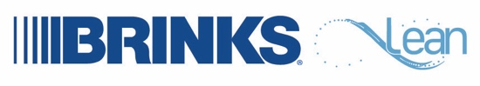

IMPLEMENTING
LEAN IN 2021

All countries across Brink’s will implement Lean in 2021, if they aren’t already doing so.
Lean is the management methodology we use to evaluate and improve processes and performance. Lean will help Brink’s drive Operational Excellence and improve customer satisfaction.
Lean is designed to empower us to:


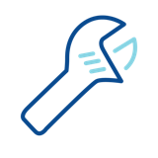

think differently
about our work
see ways we can
improve the way we work
fix or remove the frustrations we encounter as we go about our work

Lean is not about cost cutting. Lean is all about people and unlocking our potential.
The people closest to the work are the best at figuring out new and better ways to do the work.
We should go home at the end of the day feeling fulfilled and accomplished, and Lean is designed to help make this happen.
Ask your supervisor about Lean and help
get Lean started in your location!

