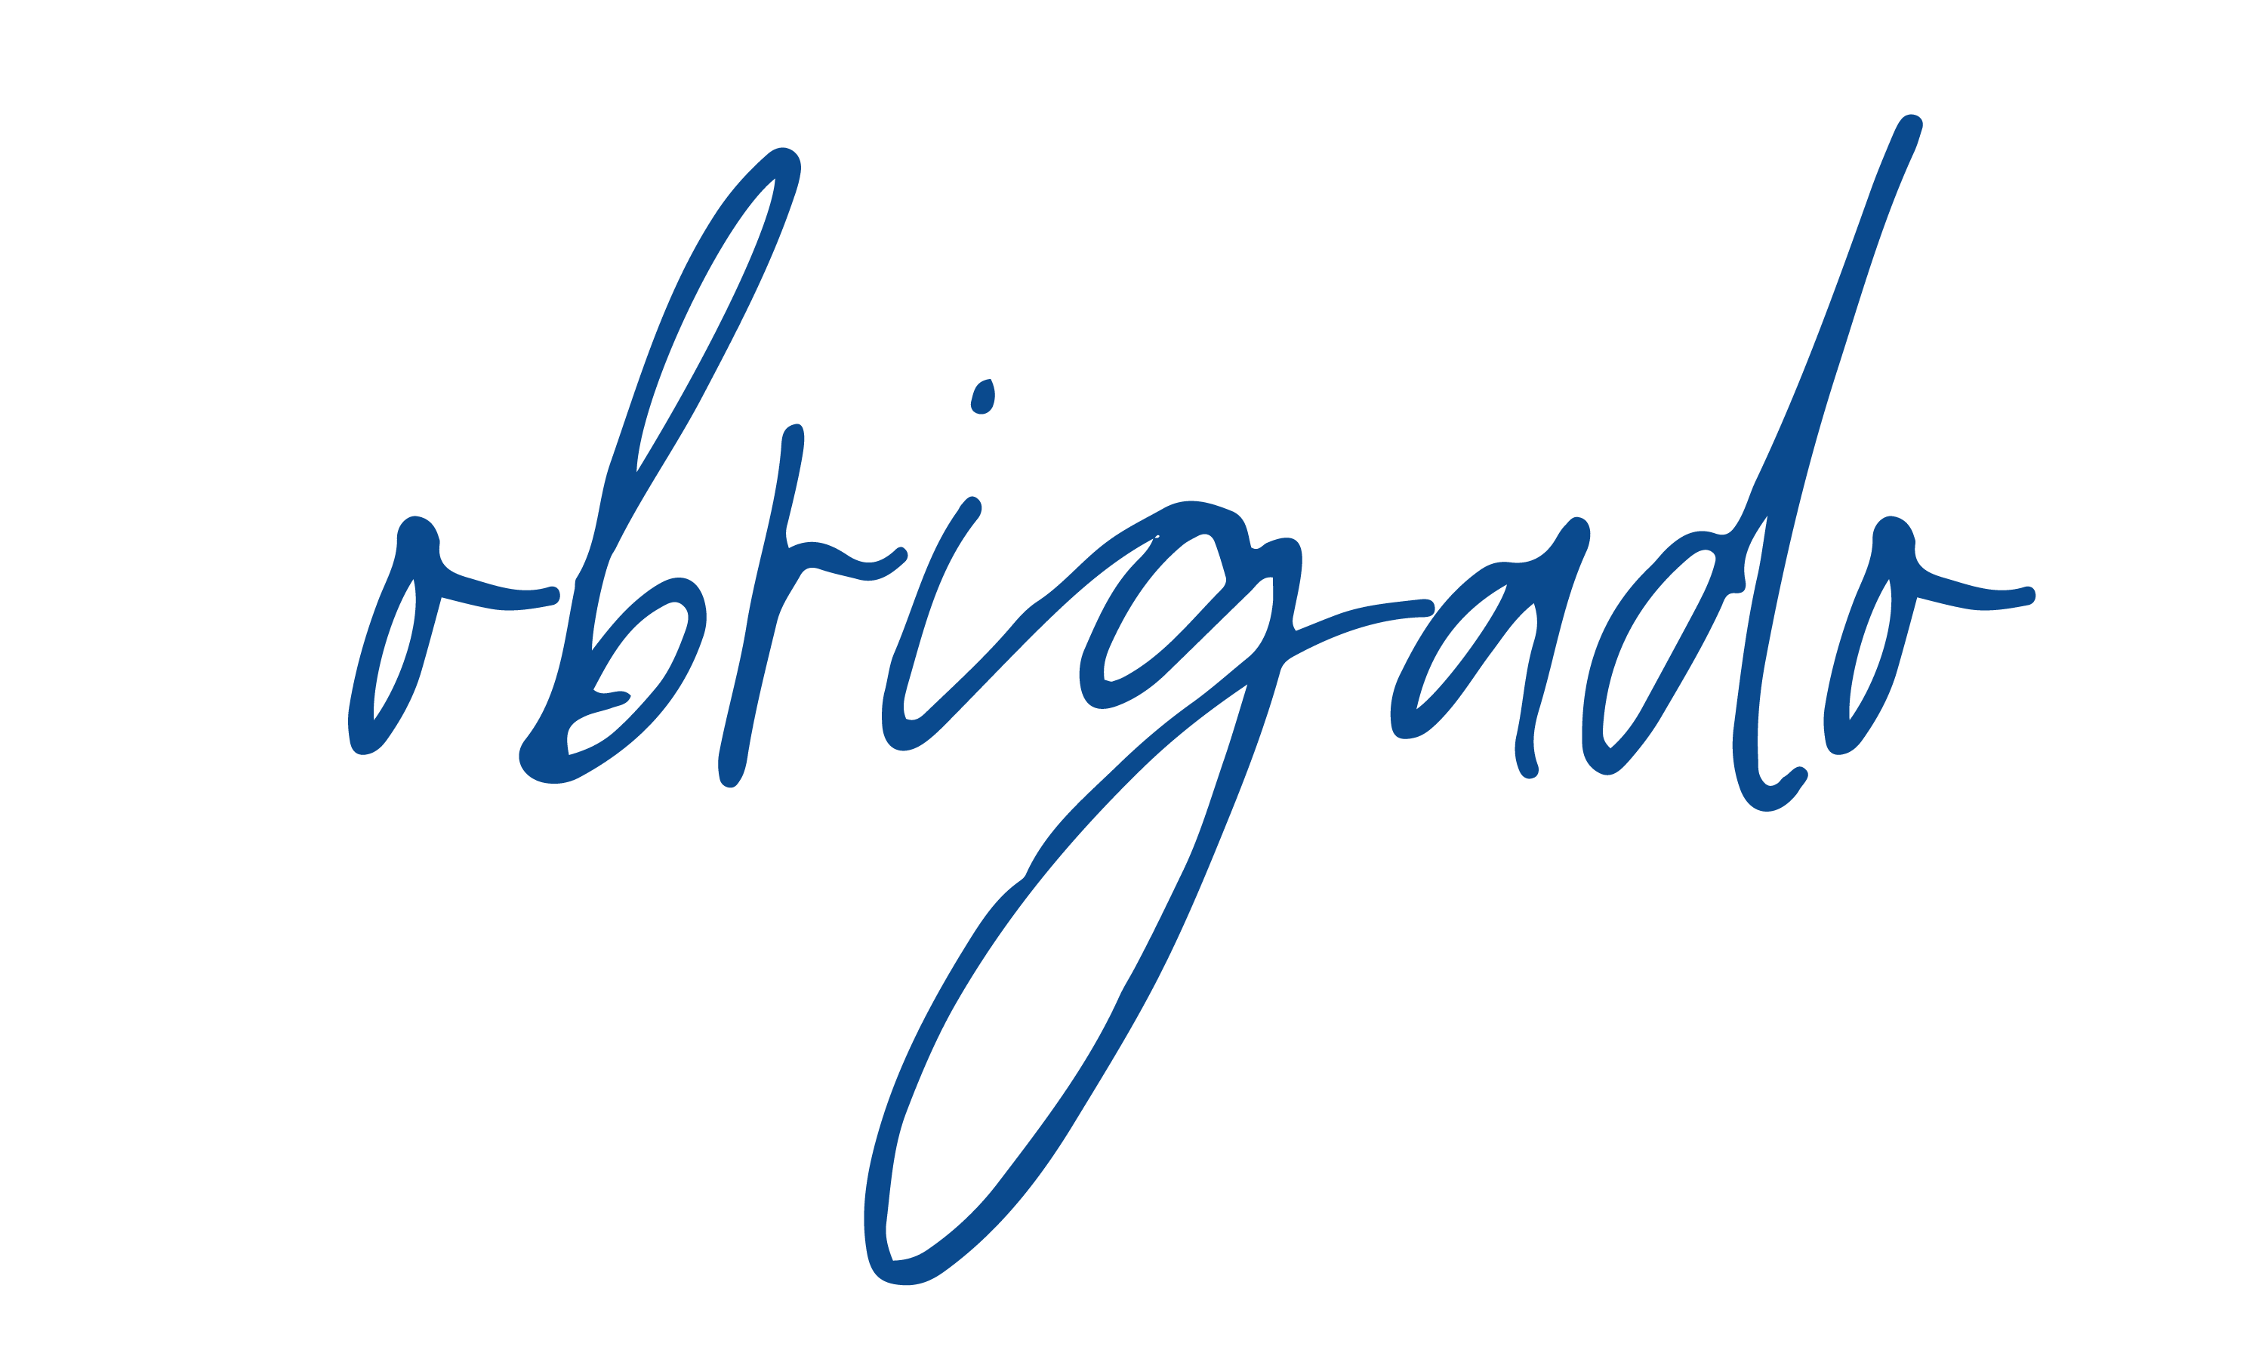

We’re celebrating 165 years of Brink’s and our awesome   
employees around the world that helped get us here.

**Thank you for all you do! The best is yet to come.**

