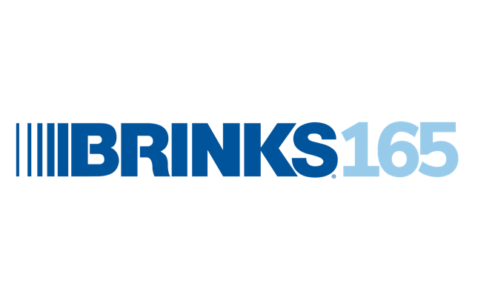


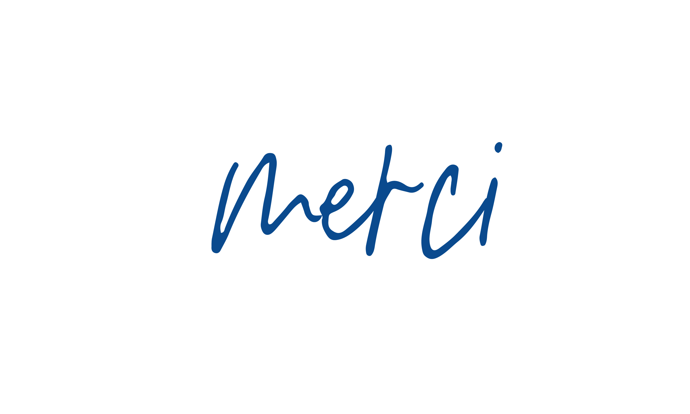

We’re celebrating 165 years of Brink’s and our awesome
employees around the world that helped get us here.
Thank you for all you do! The best is yet to come.

